Proposal: Management Announcement Web Part

Executive summary
We propose an announcement web part on the Web Portal for management. A manager picks a template, writes the announcement, chooses the Microsoft 365 users or groups who should receive it, attaches documents, and presses Post.
The system then creates a new folder for the announcement, saves the announcement and its attachments in it, and gives access only to the chosen users and groups. Recipients get an alert by email (and optionally Microsoft Teams) telling them to check the details on the Web Portal. The announcement list below the form shows each person only the announcements they are allowed to see.
The solution uses Power Apps, Power Automate and a SharePoint document library, all standard Microsoft 365 services. Estimated delivery is about 4 weeks (to be confirmed after requirements sign-off).

Requirement understanding
Management wants to publish announcements from the Web Portal to selected staff, with documents attached and access limited to those staff. This replaces the earlier "send email" idea: the announcement and its files live on the portal, and email is only the notification.
# | Requirement | How the solution meets it
1 | Management posts an announcement on the Web Portal | A "Post announcement" form on the portal, visible only to management
2 | Management selects a template | Dropdown of admin-maintained templates that fills in the title and message, which can then be edited
3 | Management chooses who receives it: internal Microsoft 365 users or groups | A people picker that searches the company directory for users and groups
4 | Management attaches documents | Attachment control on the form (several files)
5 | On submit, the system creates a new folder with the files in it | Power Automate creates one folder per announcement and saves the announcement and attachments there
6 | The folder is shown below the form | A document library web part below the form lists the announcement folders
7 | Permissions follow the users and groups management selected | The folder gets its own permissions: the selected users and groups can read it; nobody else can see it
8 | Recipients are alerted to check the details on the Web Portal | An email alert (and optionally a Teams message) with the title and an "Open on Web Portal" button; the documents stay on the portal, not in the email

Proposed solution
The solution has four parts, all standard Microsoft 365 services.
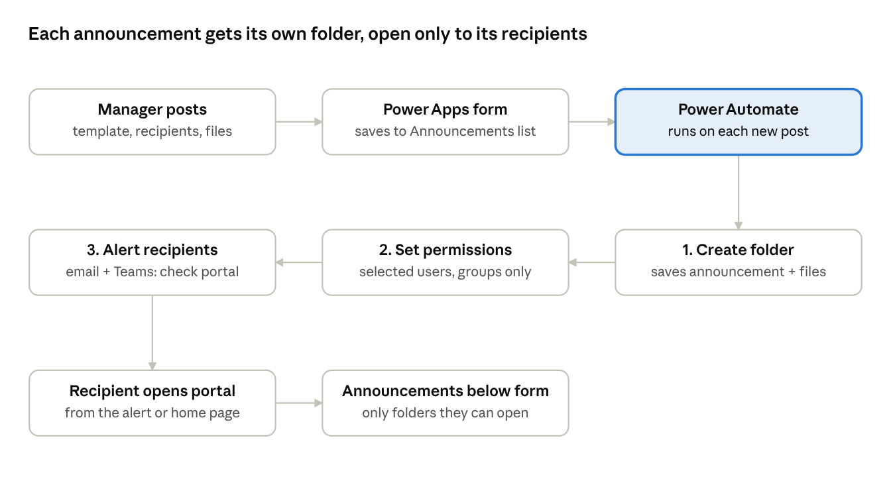
announcement flow · from post to recipient
- Post announcement form (Power Apps): embedded on the portal home page and shown only to management. It has a template dropdown, title, message, a people picker for users and groups, and attachments.
- Announcements list (SharePoint): keeps one record per announcement: who posted it, when, the recipients and the template used. This is the audit trail.
- Power Automate flow: runs when a new announcement is saved. It creates the folder, saves the announcement as a PDF plus the attachments, sets the folder's permissions, and alerts the recipients by email and, optionally, Microsoft Teams to check the portal.
- Announcements library and web part (SharePoint): one folder per announcement, shown below the form with SharePoint's document library web part. SharePoint hides folders a person has no access to, so each user only sees their own announcements.

How it works
- Manager opens the portal. Only members of the management group see the "Post announcement" form (SharePoint audience targeting); everyone else sees only the announcement list.
- Manager picks a template. The template fills in the title and message, which the manager can edit. "Blank" lets them write from scratch.
- Manager chooses recipients. They search the company directory and add people, Microsoft 365 groups or security groups, for example "All Branch Managers" or one department.
- Manager attaches documents (for example a circular, a policy PDF or a form) and presses Post.
- The system creates the folder. Power Automate creates a folder named with the date and title, for example "2026-10-22 Holiday Schedule Q4". It saves the announcement as a PDF, plus every attachment, inside it.
- The system sets permissions. The folder stops inheriting the library's permissions. The selected users and groups get Read access; the poster and portal admins keep Full Control. Nobody else can open or see the folder.
- Recipients are alerted. Each user, and each group's members, receive an email alert: "You have a new announcement on the Web Portal", with the title, who posted it, how many documents, and an "Open on Web Portal" button. The documents are not attached to the email, so they stay protected by the folder's permissions. Optionally, the same alert is posted to each person in Microsoft Teams.
- Recipients see it on the portal. The announcement list below the form shows the newest folders first. Each person only sees the folders they have access to.
If any step fails (for example a group is not found), the flow marks the announcement as "Failed" in the Announcements list and emails the poster and the portal admin, so nothing is sent half-done.

Who sees what
Every announcement folder has its own permissions, set automatically from the recipients the manager chose.
Person | Post form | Announcement list | Folder access
Management (posters) | Visible, can post | Sees all announcements they posted or received | Full Control on their own announcements
Selected users and group members | Hidden | Sees only announcements sent to them | Read: open and download
Other staff | Hidden | Does not see the announcement at all | No access
Portal admins | Visible | Sees all | Full Control, to fix or remove
Template admins | Hidden | As above | Edit the Templates list only
Group membership is checked live: if someone joins a group later, they automatically get access to that group's past announcements. If someone leaves, they lose it.

Sample user interface
The screens below show the proposed look. Names, templates and files are sample data; final wording and colours will follow the portal's style.
1. Management view of the home page. The "Post announcement" form replaces the Feedback & Suggestions banner in the right column. The manager picks a template, edits the title and message, adds users or groups, attaches files and presses Post. The new announcement appears at the top of the list below, with the groups it was shared with.
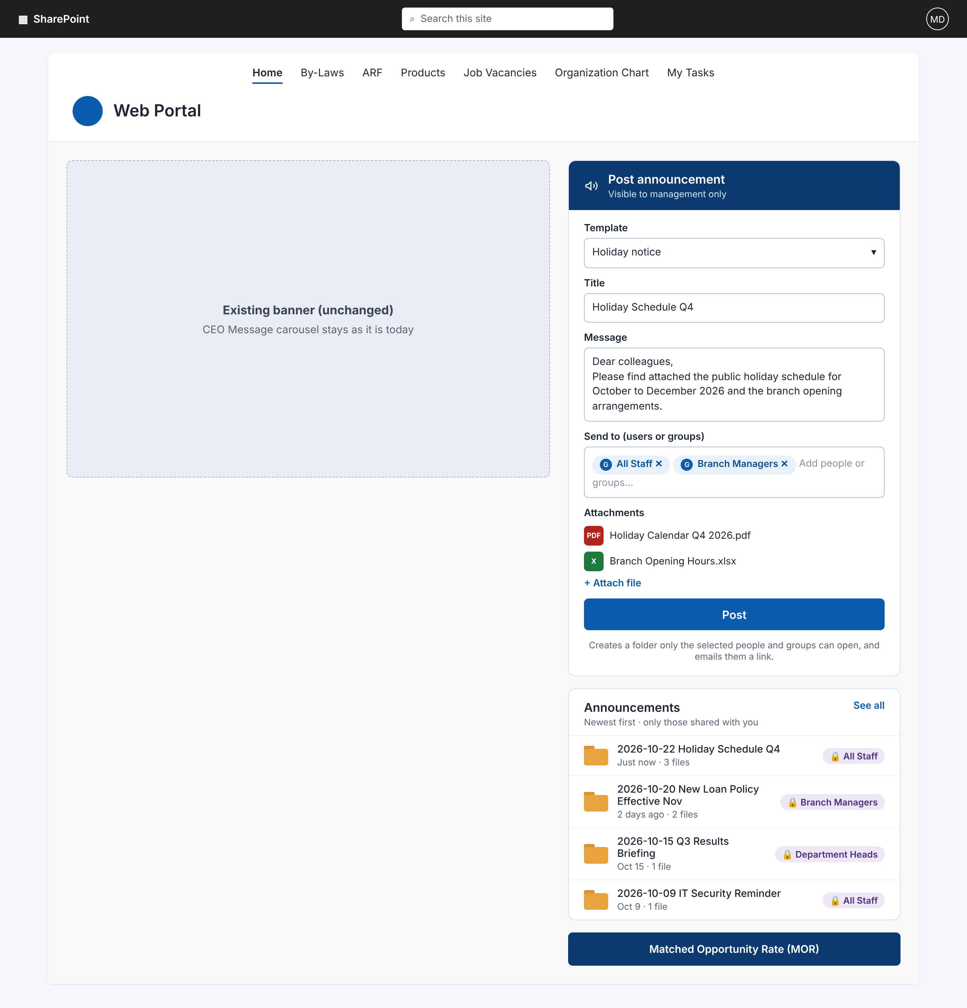
2. Staff view of the home page. Staff do not see the form. The Announcements list shows only the announcements shared with them.
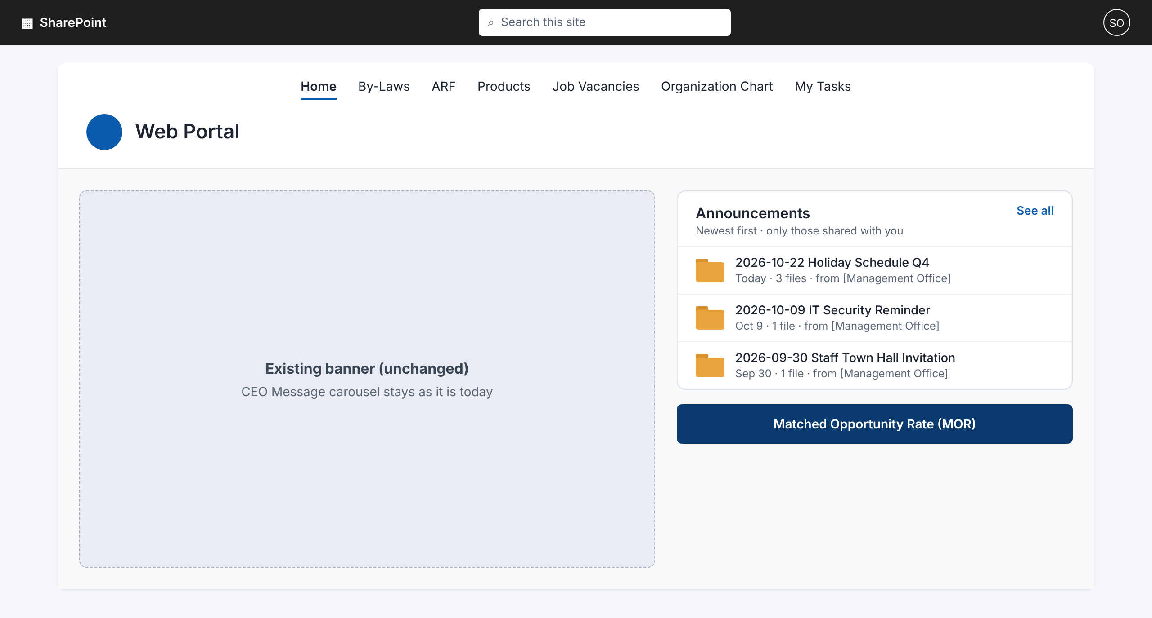
3. Inside an announcement folder. The folder holds the announcement as a PDF plus every attachment, and shows who it was shared with and who posted it.
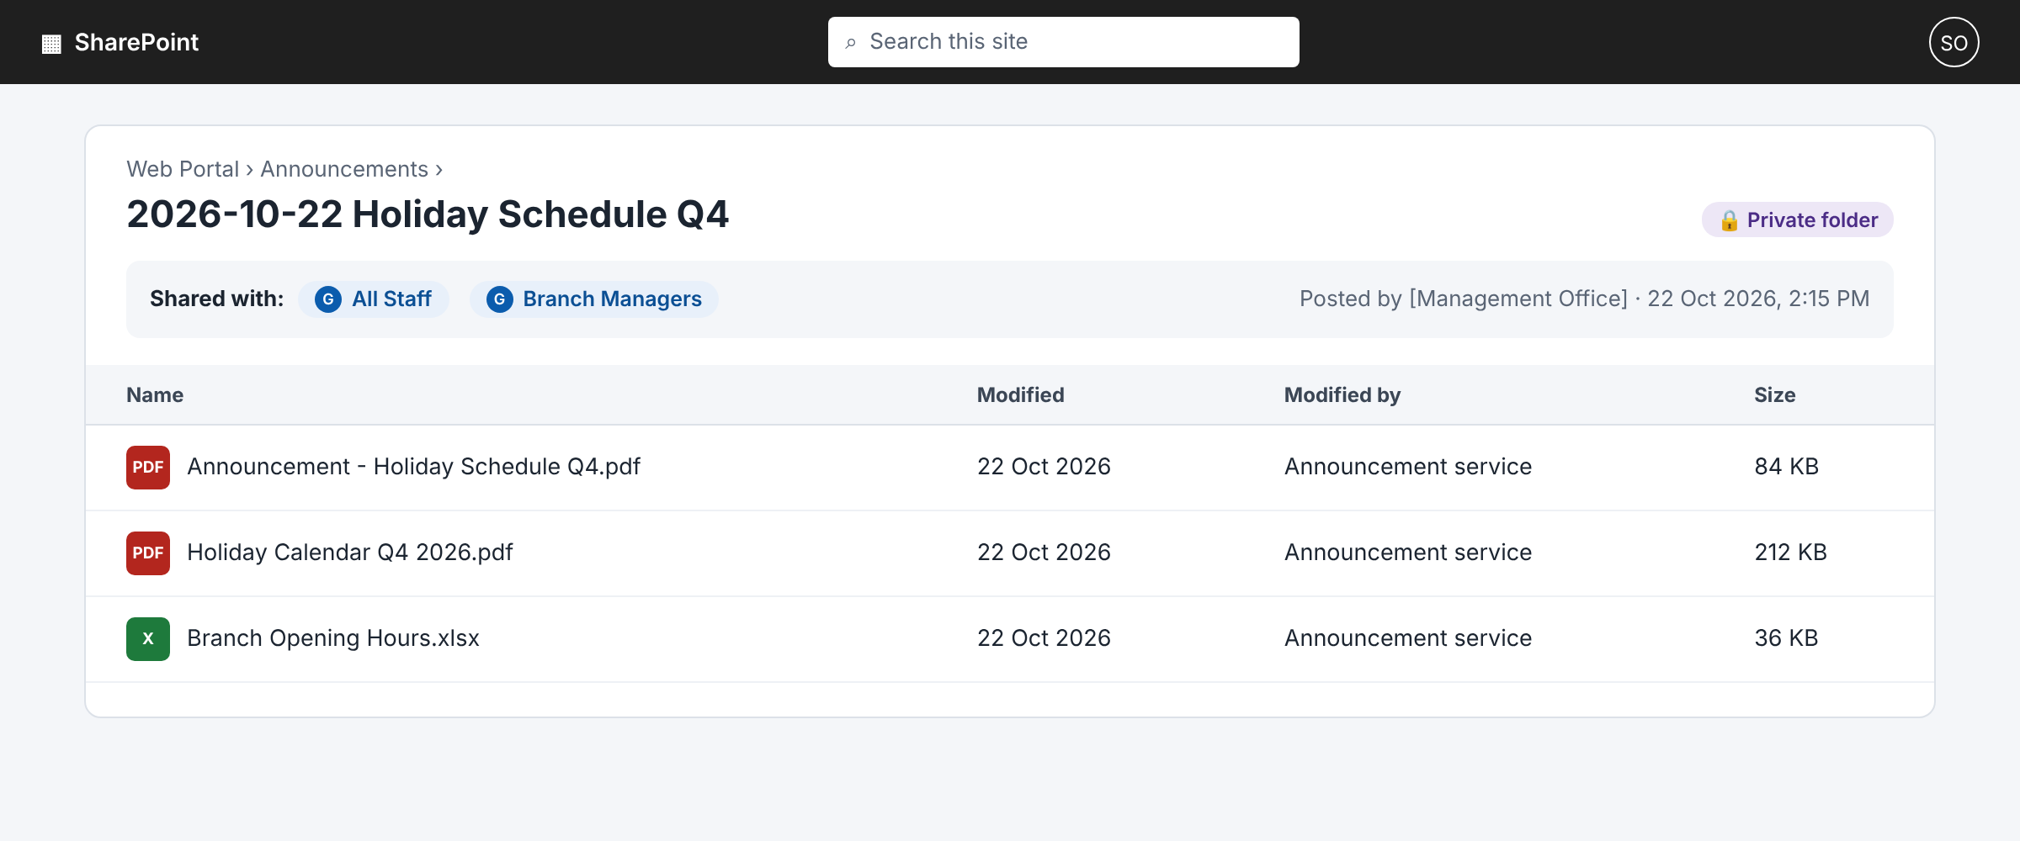
4. Alert to recipients. Recipients get an email, and optionally a Teams message, asking them to check the announcement on the Web Portal. The button opens the announcement folder; the documents are not attached to the email.
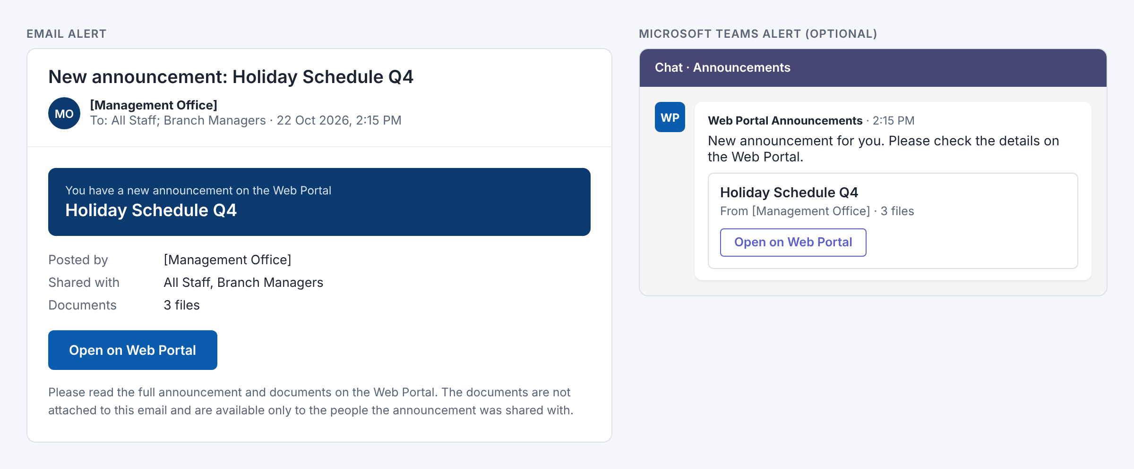

Scope of work and deliverables
In scope
- Requirements workshop with management and the portal owner (1 session)
- SharePoint setup: Announcements document library, Announcements list (audit record), Templates list with admin-only editing, and a management group
- Power Apps "Post announcement" form with template dropdown, title, rich-text message, people picker for users and groups, attachments, validation and confirmation
- Embedding the form on the portal home page with audience targeting so only management sees it
- Power Automate flow: create folder, save the announcement as PDF and the attachments, set unique folder permissions for the selected users and groups, alert recipients by email (and optionally Teams) with a link to the portal, and log success or failure
- Announcement list below the form (SharePoint document library web part), newest first
- Up to 5 starter templates supplied by the customer
- Testing, user acceptance testing (UAT) support, go-live and 2 weeks of post-go-live support
Deliverables
- Working announcement web part on the portal home page
- User guide for management (1–2 pages) and admin guide for templates and permissions
- Handover session and solution documentation
Out of scope (can be quoted separately)
- Approval workflow before an announcement is published
- Read receipts or "acknowledge" tracking per recipient
- Scheduled publishing or automatic expiry of announcements
- Sending to external (non-company) email addresses
- Editing or re-sharing an announcement after posting (a new announcement is posted instead)
- Changes to other portal pages

Implementation plan and effort
Delivery takes about 4 weeks and an estimated 15 man-days, starting from the purchase order and environment access.
Phase | Activities | Timing | Effort (man-days)
1. Requirements | Workshop; confirm templates, recipients, folder naming, email wording | Week 1 | 1
2. SharePoint setup | Library, lists, management group, permission model | Week 1 | 1
3. Post form | Power Apps form with templates, people picker, attachments; embed and audience targeting | Weeks 1–2 | 4
4. Automation | Flow for folder, PDF, attachments, folder permissions, email, error handling | Weeks 2–3 | 5
5. Testing and UAT | Internal tests with users and groups, UAT with management, fixes | Week 3 | 3
6. Go-live and handover | Deploy, guides, handover session | Week 4 | 1
Total |  | ~4 weeks | 15
Post-go-live support of 2 weeks covers defect fixes. Timing assumes the customer gives feedback and UAT sign-off within 2 working days.

Security, governance and licensing
All content stays in the customer's Microsoft 365 tenant, and access follows the recipients management selected.
- Folder-level permissions: each announcement folder has its own permissions. SharePoint search, the portal and the email link all respect them, so people who were not selected cannot find or open the files.
- Who can post: only the management group sees the form and can save to the Announcements list. The flow runs under a dedicated service account, so posters do not need edit rights on the library.
- Audit trail: the Announcements list records who posted what, when, to whom, and whether it succeeded. SharePoint version history and audit logs cover the files.
- Many unique permissions: SharePoint supports this pattern well, but performance is best when most recipients are groups rather than long lists of individuals. Microsoft recommends staying well below 50,000 uniquely-permissioned items per library; at a few announcements per day this is not reached for many years.
- Licensing: the solution uses standard connectors only (SharePoint, Office 365 Outlook, Office 365 Users and Groups, Microsoft Teams, OneDrive for Business for the PDF conversion), which are covered by Microsoft 365 licences. No premium Power Apps or Power Automate licence is needed.

Assumptions and points to confirm
Assumptions
- The Web Portal runs on SharePoint Online, and Power Apps and Power Automate are enabled.
- Recipients are internal Microsoft 365 users, Microsoft 365 groups or mail-enabled security groups.
- The announcement list replaces the Documents web part proposed earlier in the same position below the form.
- One page, one form, English-only interface.

 | Name | Signature | Date
Customer
Vendor

